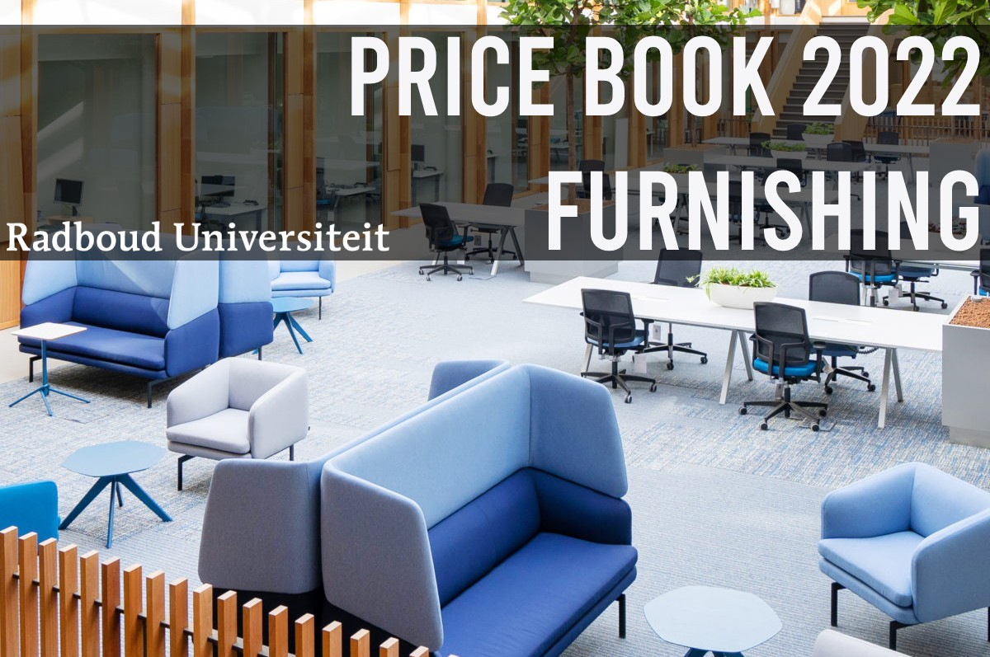

Office Furniture
Price List for 2022

CONTENTS

Work stations
Chairs
Drawer units Cabinets Conference tables
Ergonomic products Miscellaneous
PAGE
3-7
8
9
10
11
12-13
14

Workstations

Image Description

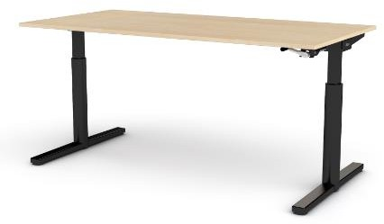
Standard Workstation Gispen TM Desk Dimensions: 160 x 80 cm
Desk top: Please indicate your choice
28mm white chipboard
28mm Egger beech chipboard
Black lacquered T-leg frame
Manual height adjustable, crank located at the front underside of the desk, 62-85 cm
Adjustable frame

Standard Workstation Gispen TM Desk Dimensions 180 x 80 cm
Desk top: Please indicate your choice
28mm white chipboard
28mm Egger beech chipboard
Lacquered T-leg frame in black
Manual height adjustable, crank located at the front underside of the desk, 62-85 cm
Adjustable frame

Price inclusive of VAT

€468.00

€495.00

Workstations

Image Description Price inclusive of VAT

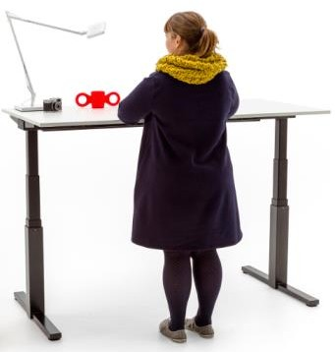
Standard Workstation Gispen TM Desk Dimensions: 160 x 80 cm
Desk top: Please indicate your choice
18mm white chipboard
28mm Egger beech chipboard
Black lacquered T-leg frame
Sitting/standing adjustable desk, 62-130 cm Adjustable frame

Standard Workstation Gispen TM Desk Dimensions: 180 x 80 cm
Desk top: Please indicate your choice
18mm white chipboard
28mm Egger beech chipboard
Black lacquered T-leg frame
Sitting/standing adjustable desk, 62-130 cm Adjustable frame
€1,028.00

€1,049.00

Workstations

Image Description

Frame type: Oxford
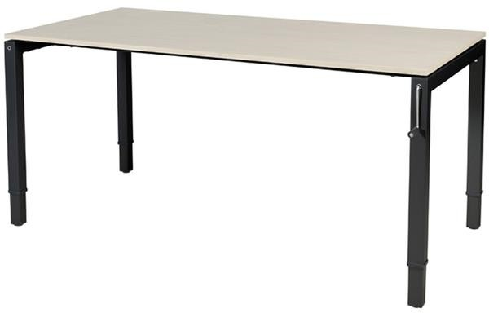
Height adjustable from 63 to 92 cm by means of a crank
Dimensions 160 x 80 cm
Desk top: Please indicate your choice
28mm white chipboard
28mm Egger beech chipboard
Black lacquered frame

Frame type: Oxford
Height adjustable from 63 to 92 cm by means of a crank
Dimensions: 180 x 80 cm
Desk top: Please indicate your choice
28mm white chipboard
28mm Egger beech chipboard
Black lacquered frame

Price inclusive of VAT

€731.00

€750.00

Workstations

Image Description Price inclusive of VAT

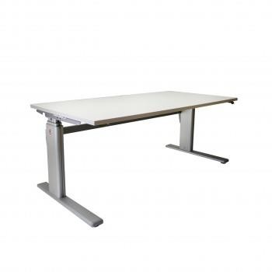
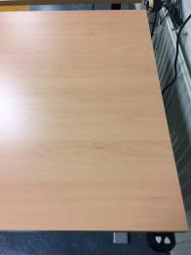
Frame type: Er-T-Go sit-stand (LKV Culemborg) Electrically height adjustable from 63 to 128 cm
Silvery grey lacquered frame Dimensions: 160 x 80 cm
Desk top: Please indicate your choice
28mm white chipboard
28mm Egger beech chipboard

Frame type: Er-T-Go sit-stand (LKV Culemborg) Electrically height adjustable from 63 to 128 cm
Silvery grey lacquered frame Dimensions: 180 x 80 cm
Desk top: Please indicate your choice
28mm white chipboard
28mm Egger beech chipboard
€1,070.00

€1,089.00

Workstations

Image Description Price inclusive of VAT

Cable tray, width: 130 cm
Black lacquered finish
€62.00

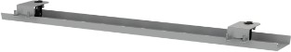

Chairs

Image Description Price inclusive of VAT

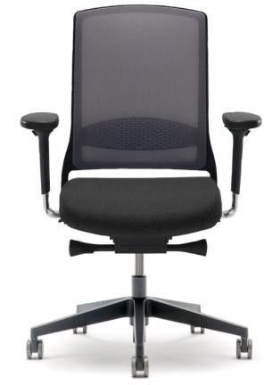
Gispen Zinn Office Chair
NPR 35D
Synchronised mechanism
4D armrests
Black plastic cross foot
Seat upholstered in black Citadel fabric Back covered in Black Runner Netweave Complies with NPR 1813

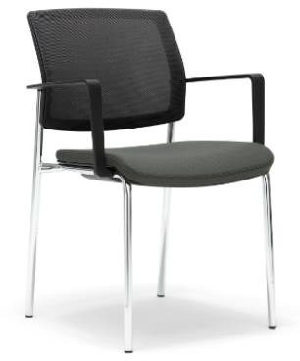
Gispen Zinn Visitor Chair
Four leg frame
Aluminium lacquered frame
Includes armrests
Seat upholstered in black Citadel fabric Back covered in Black Runner Netweave

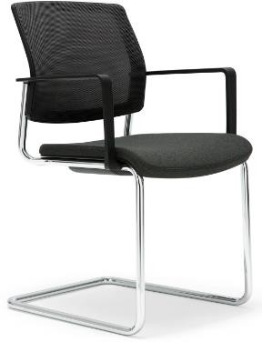
Gispen Zinn Visitor Chair
Sled frame
Aluminium lacquered frame
Includes armrests
Seat upholstered in black or blue Citadel fabric
Back covered in Black Runner Netweave
€451.00

€287.00

€302.00

Draw units

Image Description Price inclusive of VAT

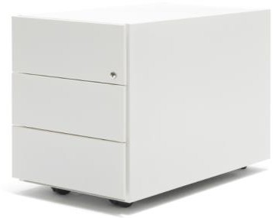
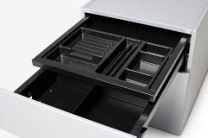
Gispen Draw Unit Dimensions: 42 x 60 cm
Three identical drawers, including a supply drawer
Lacquered steel body and fronts Colour: Black
Includes steel top Mobile

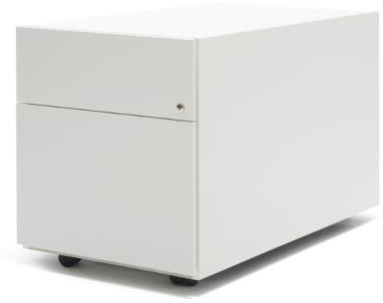
Gispen Draw Unit Dimensions: 42 x 60 cm
Includes a paper drawer, suspension file draw and a supply drawer
Lacquered steel body and fronts Colour: Black
Includes steel top Mobile
€394.00

€361.00

Cabinets

Image Description Price inclusive of VAT

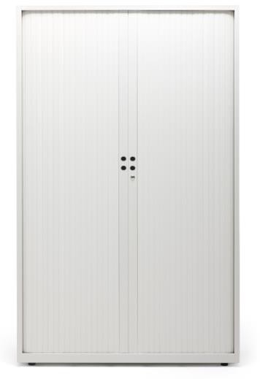
High tambour door cabinet
Gispen Meta Cabinet Dimensions: 195 x 120 cm Depth: 47 cm
Lacquered tambour doors and body Colour: Black or white
Includes four shelves
Can be adjusted from the inside

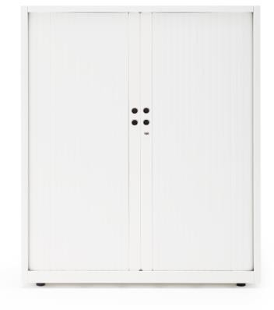
Low tambour door cabinet
Gispen Meta Cabinet Dimensions: 120 x 120 cm Depth: 47 cm
Lacquered tambour doors and body Colour: Black or white
Includes two shelves
Can be adjusted from the inside
€594.00

€398.00

Conference Tables

Image Description Price inclusive of VAT

Gispen UT Table
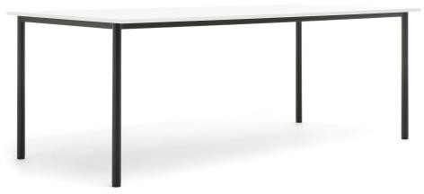
Welded frame with 30 mm round legs Round legs with integrated height adjustment
Black lacquered frame
Dimensions: 120 x 80 cm
Table top: Please indicate your choice
28mm white chipboard
28mm Egger beech chipboard

Gispen UT Table
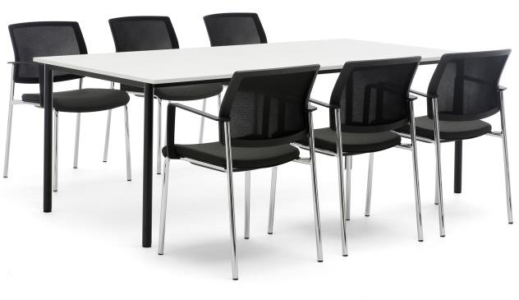
Welded frame with 30 mm round legs Round legs with integrated height adjustment
Black lacquered frame
Dimensions 160 x 80 cm
Table top: Please indicate your choice
28mm white chipboard
28mm Egger beech chipboard
€387.00

€428.00

Ergonomic products

Image Description Price inclusive of VAT

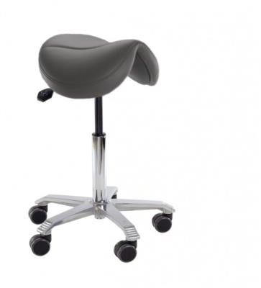
Score Jumper Saddle Stool
(with a wide seat)
Aluminium base, diameter: 54 cm
Adjustable sitting angle
Soft wheels (65 mm)
Black artificial leather seat

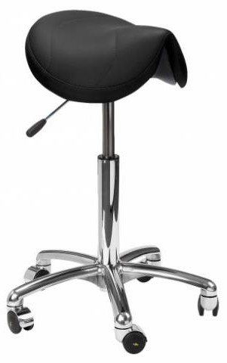
Score Amazone Saddle Stool
(with a narrow seat)
Aluminium base, diameter: 54 cm
Adjustable sitting angle
Soft wheels (65 mm)
Black artificial leather seat
€410.00

€410.00

Ergonomic products

Image Description Price inclusive of VAT

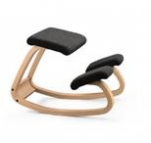
Varier Stokke Balans Kneeling Chair
Mechanism: Rocking chair
Frame: Natural wood
Black upholstery

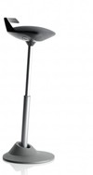
Muvman Stool
Sit/stand support
Adjustable sitting angle
Silver coloured base
Black upholstery

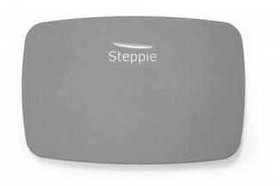
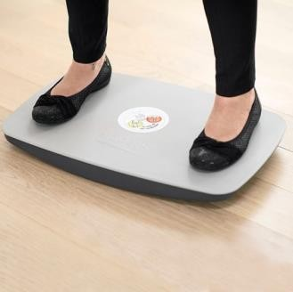
Balance Board
Type: Steppie Colour: Dark grey
€620.00

€513.00

€225.00

Miscellaneous

Image Description Price inclusive of VAT

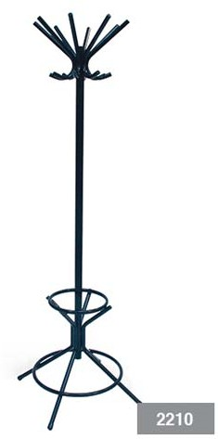
Upright coat stand Type: 2210 PURE
Number of hooks: 8
Black lacquered steel (RAL9005)
Includes umbrella ring

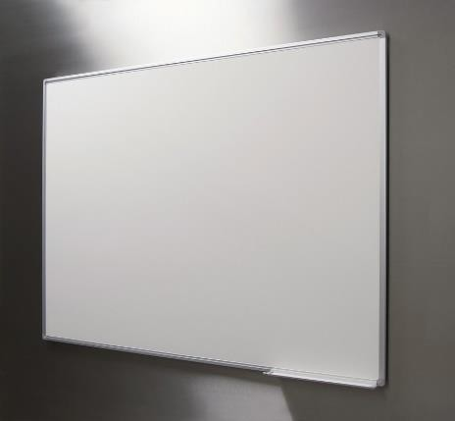
Whiteboard
Does not include wall-mounting hardware

Dimensions: 120 x 90 cm Dimensions: 90 x 60 cm
€127.00

-
€157.00
€116.00

Any desk that is assembled or moved must comply with the university’s guidelines for cable management. If cables need to be installed, there will be additional costs.

Prices for floor coverings, paintwork and signage will be agreed on the basis of an estimate.

White and beech white are the standard stock colours for desk tops and table tops. Other colours are available; these will require a longer delivery time and are available at a different price. Frames and bases are also available in other colours; these will require a longer delivery time and are available at a different price.

This price list contains details of our most popular products. Most of these products are in stock, which allows for quick delivery times. Please feel free to contact us about other products or if you require advice.

Office furniture // Robin.timmerman@ru.nl // Jeremy.maassen@ru.nl

